**Lab Number: 07 Date: 2025/08/17**

# Title: Creating different network topologies using Packet Tracer

# Theory:

Network topology defines the arrangement of network devices and the communication paths between them. It outlines the physical or logical structure of a network. Understanding different topologies is crucial for designing network systems.

1. **Different types of Network Topologies:**
   * 1. Bus Topology
     2. Ring Topology
     3. Star Topology
     4. Mesh Topology, etc.
2. **Ring Topology**

Ring topology is a network configuration where devices are connected in a circular manner, forming a closed loop. Each device is connected to exactly two other devices, creating a continuous pathway for data transmission.

**Component Used**

**Hardware:** Switches (4), Ethernet cables, End devices (4).

**Software:** Cisco Packet Tracer

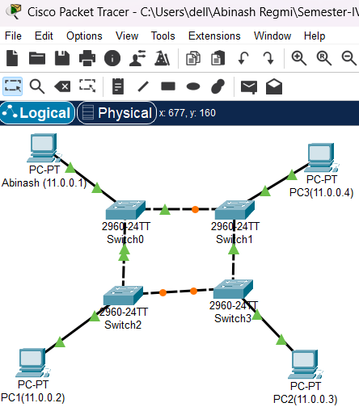**Network Diagram**

Fig: Network map for Ring Topology

**Procedure**

Here is the procedure for creating the Ring Topology shown in the image using Cisco Packet Tracer:

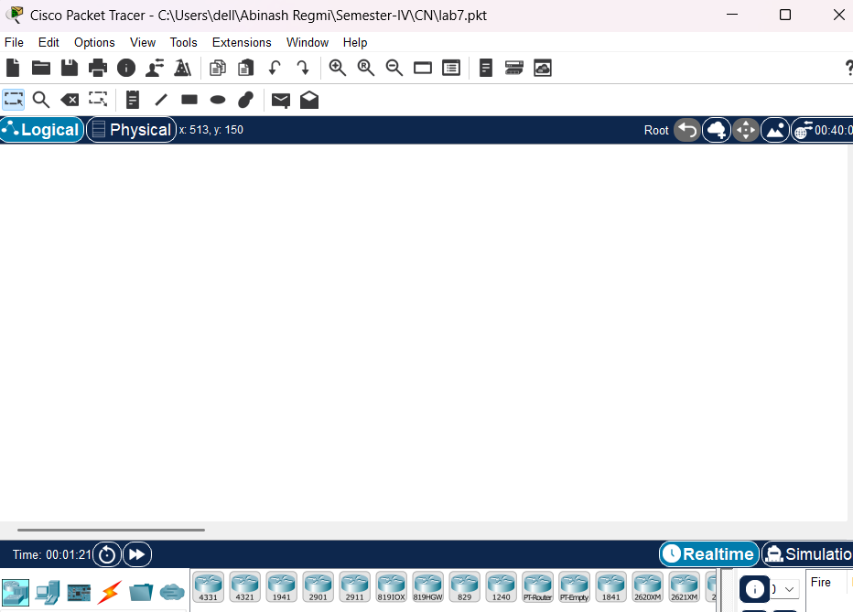**Step 1: Launch Cisco Packet Tracer**

Fig: Workspace for network design

**Step 2: Add the network devices to the workspace**

2.1 From the Device-Type Selection box, choose the following devices and add them to the workspace:

2.2 Four 2690-24TT Switch

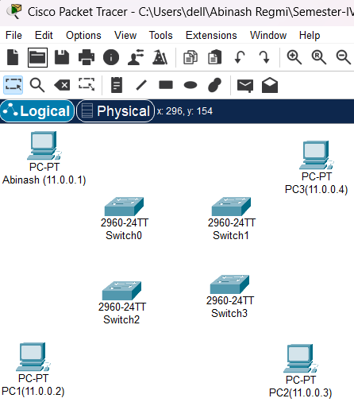 2.3 Four PCs (labeled Abinash, PC1, PC2, and PC3)

Fig: Switches and PC’s for Ring Topology

**Step 3: Connect the devices**

3.1 Use the copper straight-through cable to connect each PC to one of the available ports on each switch and copper cross-over cable to connect between each switch.

 3.2 Ensure that each connection is made properly.

Fig: Connection between Switch and PC’s

**Step 4: Configure IP address**

4.1 Right-click on each PC and select “IP Configuration”.

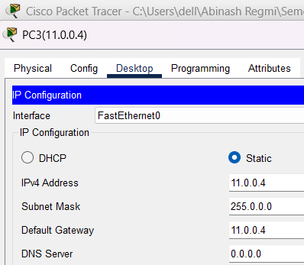 4.2 In the IP configuration window, enter the IP address as (11.0.0.1 to 11.0.0.4), subnet mask, and default gateway for each PC.

Fig: IP configuration

**Step 5: Verify connectivity:**

5.1 To test whether the network is working, you can ping other devices on the network from each PC.

5.2 To ping another device, open a command prompt on the PC and type “ping” <IP address of the other device>”.

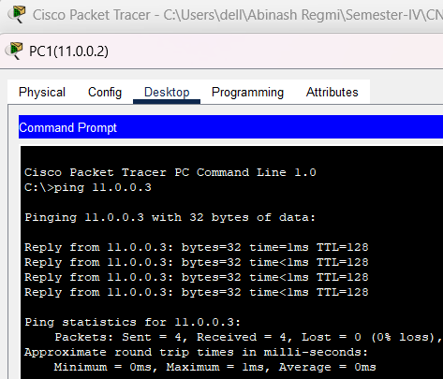 5.3 If the ping is successful, you should see replies from the other device.

Fig: Connectivity test between PC1 and PC2

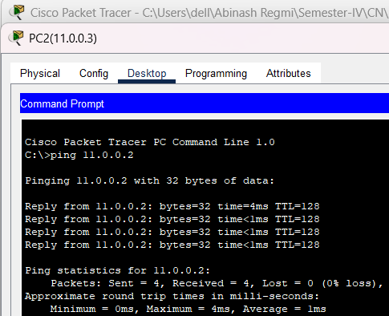

Fig: Connectivity test between PC2 and PC1

1. **Star Topology**

Star Topology is a network configuration where all devices are connected to a central hub or switch. This central device acts as a communication hub for all connected devices.

**Components Used**

**Hardware:** Switches (1), Ethernet cables, End devices (5).

**Software:** Cisco Packet Tracer

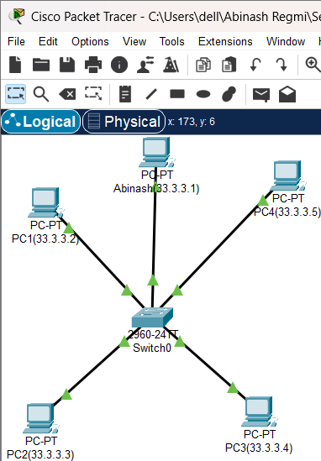**Network Diagram**

Fig: Network Map for Star Topology

**Procedure**

Here is the procedure for creating the Star Topology shown in the image using Cisco

Packet Tracer:

**Step 1: Launch Cisco Packet Tracer**

fig: Workspace for network design

**Step 2: Add the network devices to the workspace**

2.1 From the Device-Type Selection box, choose the following devices and add them to the workspace:

2.2 One 2690-24TT Switch

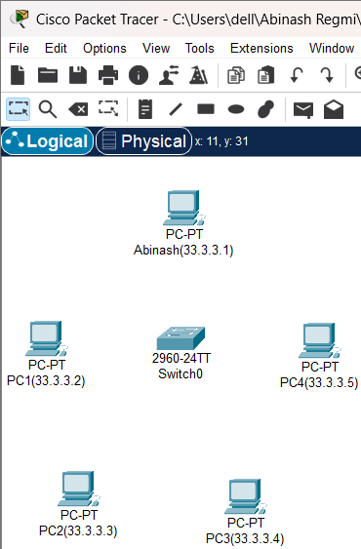 2.3 Five PC’s (labeled Abinash, PC1, PC2, PC3 and PC4)

Fig: Switches and PCs for Star Topology

**Step 3: Connect the devices**

3.1 Use the copper straight-through cable to connect each PC to one of the available ports on the switch

 3.2 Ensure that each connection is made properly.

Fig: Connection between Switch and PC’s

**Step 4: Configure IP addresses**

4.1 Right-click on each PC and select “IP Configuration”.

4.2 In the IP Configuration window, enter the IP address as (33.3.3.1 to 33.3.3.5), subnet mask, and default gateway for each PC.

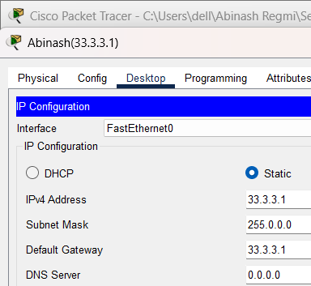

Fig: IP configuration

**Step 5: Verify connectivity:**

5.1 To test whether the network is working, you can ping other devices on the network from each PC.

5.2 To ping another device, open a command prompt on the PC and type “ping” <IP address of the other device>”.

5.3 If the ping is successful, you should see replies from the other device.

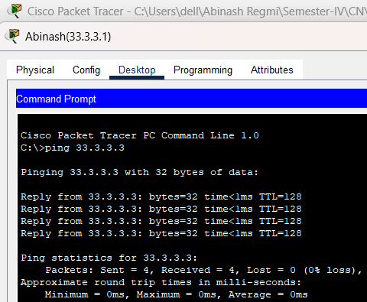

Fig: Connectivity test between Abinash and PC2

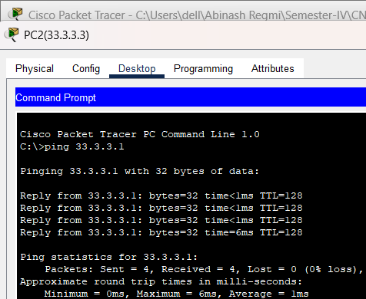

Fig: Connectivity test between PC2 and Abinash

1. **Mesh Topology**

Mesh topology is a network configuration where every device is connected to every other device. This creates a highly interconnected network with multiple paths for data transmission.

**Component Used**

**Hardware:** Switches (4), Ethernet cables, End devices (4).

**Software:** Cisco Packet Tracer

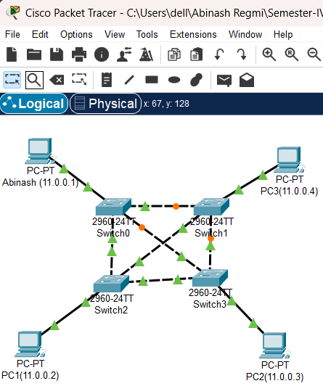**Network Diagram**

Fig: Network Map for Mesh Topology

**Procedure**

Here is the procedure for creating the Mesh Topology shown in the image using Cisco Packet Tracer.

**Step 1: Launch Cisco Packet Tracer**



Fig: Workspace for network design

**Step 2: Add the network devices to the workspace**

2.1 From the Device-Type Selection box, choose the following devices and add them to the workspace:

2.2 Four 2690-24TT Switch

 2.3 Four PCs (labeled Abinash, PC1, PC2, and PC4)

Fig: Switches and PCs for Mesh Topology

**Step 3: Connect the devices**

3.1 Use the copper straight-through cable to connect each PC to one of the available ports on each switch and copper cross-over cable to connect between each adjacent and diagonal switches.

3.2 Ensure that each connection is made properly.



Fig: Connection between Switch and PC’s

**Step 4: Configure IP addresses**

4.1 Right-click on each PC and select “IP Configuration”.

4.2 In the IP Configuration window, enter the IP address as (11.0.0.1 to 11.0.0.4), subnet mask, and default gateway for each PC.



Fig: IP configuration

**Step 5: Verify connectivity:**

5.1 To test whether the network is working, you can ping other devices on the network from each PC.

5.2 To ping another device, open a command prompt on the PC and type “ping <IP address of the other device>”.

5.2 If the ping is successful, you should see replies from the other device.

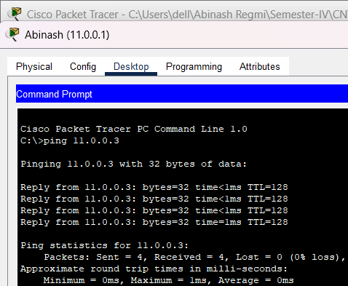

Fig: Connectivity test between Abinash and PC2

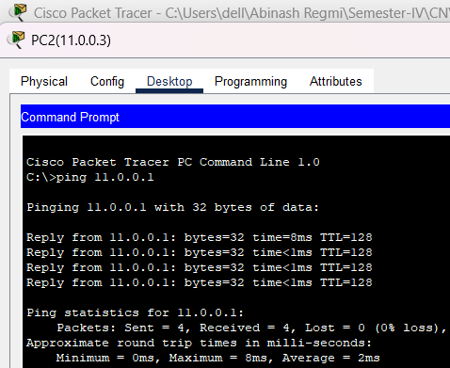

Fig: Connectivity test between PC2 and Abinash

**Conclusion**

Creating different topologies in Cisco Packet Tracer provides a hands-on understanding of how devices within a network topology are interconnected and how they communicate with each other. Through this process, we can simulate the design and configuration of different topologies, including the placement and connection of key components such as switches, and end devices. Testing the connectivity within the simulated environment allows to ensure that the network is properly configured, with data flowing smoothly between devices.